IOT ENABLED SMART FARMING

APPLICATION.

Sprint Delivery – 1 TEAM ID : **PNT2022TMID40725**

# Introduction

The main aim of this project is to help farmers automate their farms by providing them with a Web App through which they can monitor the parameters of the field like Temperature, soil moisture, humidity and etc and control the equipment like water motor and other devices remotely via internet without their actual presence in the field.

# Problem Statement

Farmers are to be present at farm for its maintenance irrespective of the weather conditions. They have to ensure that the crops are well watered and the farm status is monitored by them physically. Farmer have to stay most of the time in field in order to get a good yield. In difficult times like in the presence of pandemic also they have to work hard in their fields risking their lives to provide food for the country.

# Proposed Solution

In order to improve the farmer’s working conditions and make them easier, we introduce IoT services to him in which we use cloud services and internet to enable farmer to continue his work remotely via internet. He can monitor the field parameters and control the devices in farm.

# Theoretical Analysis

* 1. Block Diagram

In order to implement the solution , the following approach as shown in the block diagram is used

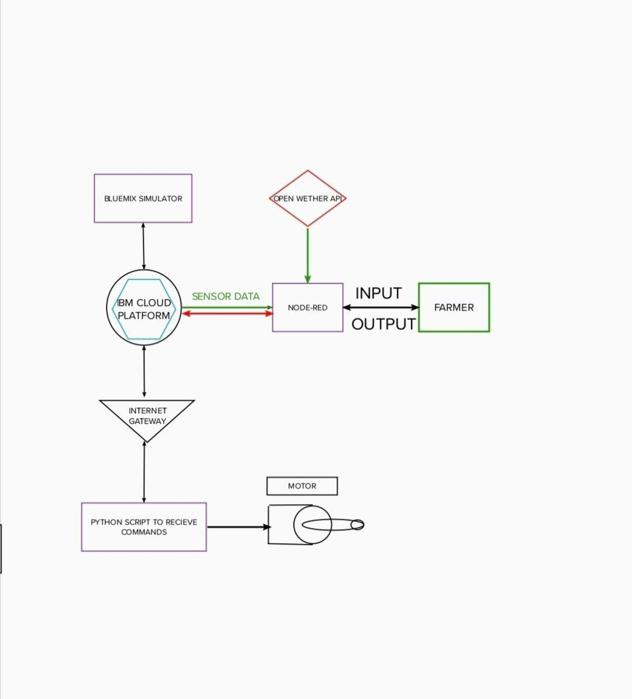

# Required Software Installation

* + 1. Node-Red

Node-RED is a flow-based development tool for visual programming developed originally by IBM for wiring together hardware devices, APIs and online services as

part of the Internet of Things. Node-RED provides a web browser-based flow editor, which can be used to create JavaScript functions.

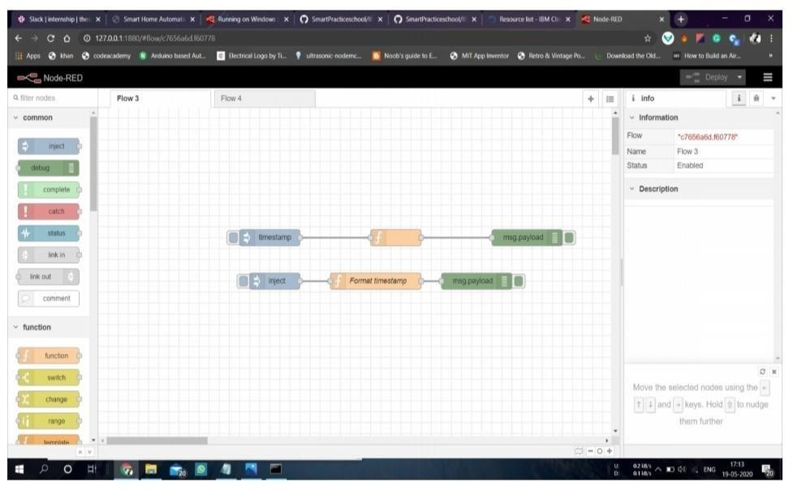

**Installation :**

* First install npm/node.js
* Open cmd prompt
* Type => npm install node-red

**To run the application :**

* Open cmd prompt
* Type=>node-red
* Then open http://localhost:1880/ in browser

**Installation of IBM IoT and Dashboard nodes for Node-Red**

In order to connect to IBM Watson IoT platform and create the Web App UI these nodes are required 1. IBM IoT node

2. Dashboard node

# IBM Watson IoT Platform

A fully managed, cloud-hosted service with capabilities for device registration, connectivity, control, rapid visualization and data storage. IBM Watson IoT Platform is a managed, cloud-hosted service designed to make it simple to derive value from your IoT devices.

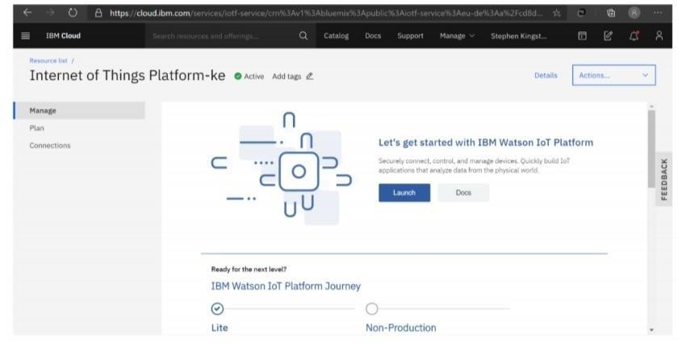

**Steps to configure:**

* Create an account in IBM cloud using your email ID
* Create IBM Watson Platform in services in your IBM cloud account
* Launch the IBM Watson IoT Platform
* Create a new device
* Give credentials like device type, device ID, Auth. Token
* Create API key and store API key and token elsewhere.

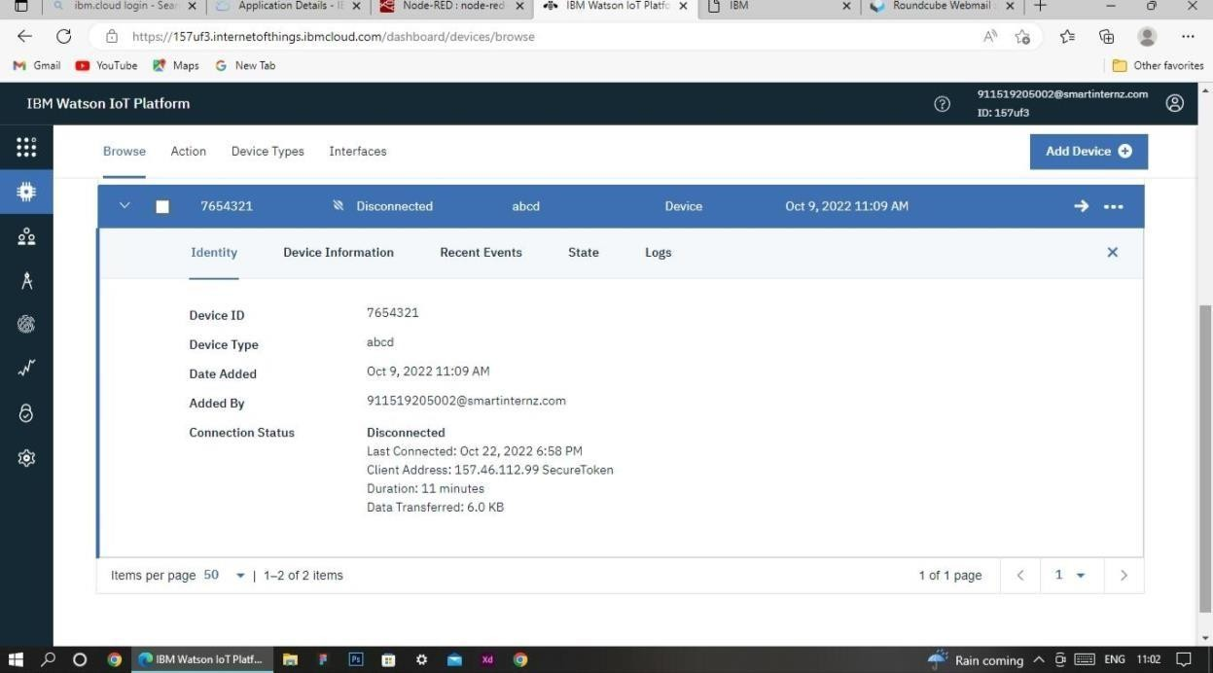

# Python IDE

Install Python3 compiler

Install any python IDE to execute python scripts, in my case I used Spyder to execute the code.

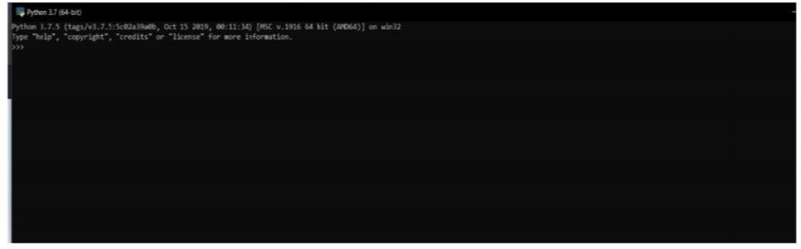

Code: import time import sys import ibmiotf.application import ibmiotf.device import random

#Provide your IBM Watson Device Credentials organization = "157uf3" deviceType = "abcd" deviceId = "7654321" authMethod = "token" authToken = "87654321"

# Initialize GPIO

def myCommandCallback(cmd): print("Command received: %s" % cmd.data['command']) status=cmd.data['command'] if status=="motoron": print ("motor is on") elif status == "motoroff": print ("motor is off") else :

print ("please send proper command")

try:

deviceOptions = {"org": organization, "type": deviceType, "id": deviceId,

"auth-method": authMethod, "auth-token": authToken} deviceCli = ibmiotf.device.Client(deviceOptions)

#..............................................

except Exception as e:

print("Caught exception connecting device: %s" % str(e)) sys.exit()

# Connect and send a datapoint "hello" with value "world" into the cloud as an event of type "greeting" 10 times deviceCli.connect()

while True:

#Get Sensor Data from DHT11

temp=random.randint(90,110) Humid=random.randint(60,100)

Mois=random.randint(20,120)

data = { 'temp' : temp, 'Humid': Humid, 'Mois' :Mois} #print data def

myOnPublishCallback():

print ("Published Temperature

= %s C" % temp, "Humidity = %s

%%" % Humid, "Moisture =%s deg c" %Mois, "to IBM Watson")

success = deviceCli.publishEvent("IoTSensor", "json", data, qos=0, on_publish=myOnPublishCallback) if not success: print("Not connected to IoTF") time.sleep(10)

deviceCli.commandCallback = myCommandCallback

# Disconnect the device and application from the cloud deviceCli.disconnect()

**Aurdino code for C :**

**//include libraries #include <dht.h>**

**#include <SoftwareSerial.h>**

**//define pins**

**#define dht_apin A0 // Analog Pin sensor is connected SoftwareSerial mySerial(7,8);//serial port of gsm**

**const int sensor_pin = A1; // Soil moisture sensor O/P pin int pin_out = 9;**

**//allocate variables dht DHT;**

**int c=0;**

**void setup()**

**{**

**pinMode(2, INPUT); //Pin 2 as INPUT pinMode(3, OUTPUT); //PIN 3 as OUTPUT pinMode(9, OUTPUT);//output for pump**

**}**

**void loop()**

**{**

**if (digitalRead(2) == HIGH)**

**{**

**digitalWrite(3, HIGH); // turn the LED/Buzz ON delay(10000); // wait for 100 msecond digitalWrite(3, LOW); // turn the LED/Buzz OFF delay(100);**

**}**

**Serial.begin(9600); delay(1000);**

**DHT.read11(dht_apin); //temprature float h=DHT.humidity;**

**float t=DHT.temperature; delay(5000); Serial.begin(9600);**

**float moisture_percentage;//moisture int sensor_analog;**

**sensor_analog = analogRead(sensor_pin);**

**moisture_percentage = ( 100 - ( (sensor_analog/1023.00) * 100 ) );**

**float m=moisture_percentage; delay(1000);**

**if(m<40)//pump**

**{**

**while(m<40)**

**{**

**digitalWrite(pin_out,HIGH);//open pump sensor_analog = analogRead(sensor_pin);**

**moisture_percentage = ( 100 - ( (sensor_analog/1023.00) * 100 ) ); m=moisture_percentage;**

**delay(1000);**

**}**

**digitalWrite(pin_out,LOW);//closepump**

**}**

**if(c>=0)**

**{**

**mySerial.begin(9600); delay(15000); Serial.begin(9600); delay(1000); Serial.print("\r"); delay(1000); Serial.print("AT+CMGF=1\r"); delay(1000);**

**Serial.print("AT+CMGS=\"+XXXXXXXXXX\"\r"); //replace X with 10 digit mobil e number**

**delay(1000); Serial.print((String)"update-**

**>"+(String)"Temprature="+t+(String)"Humidity="+h+(String)"Moisture="+m); delay(1000);**

**Serial.write(0x1A); delay(1000);**

**mySerial.println("AT+CMGF=1");//Sets the GSM Module in Text Mode delay(1000);**

**mySerial.println("AT+CMGS=\"+XXXXXXXXXX\"\r"); //replace X with 10 digit mobile number**

**delay(1000); mySerial.println((String)"update-**

**>"+(String)"Temprature="+t+(String)"Humidity="+h+(String)"Moisture="+m);// message format**

**mySerial.println(); delay(100); Serial.write(0x1A); delay(1000);**

**c++;**

**}**

**}**

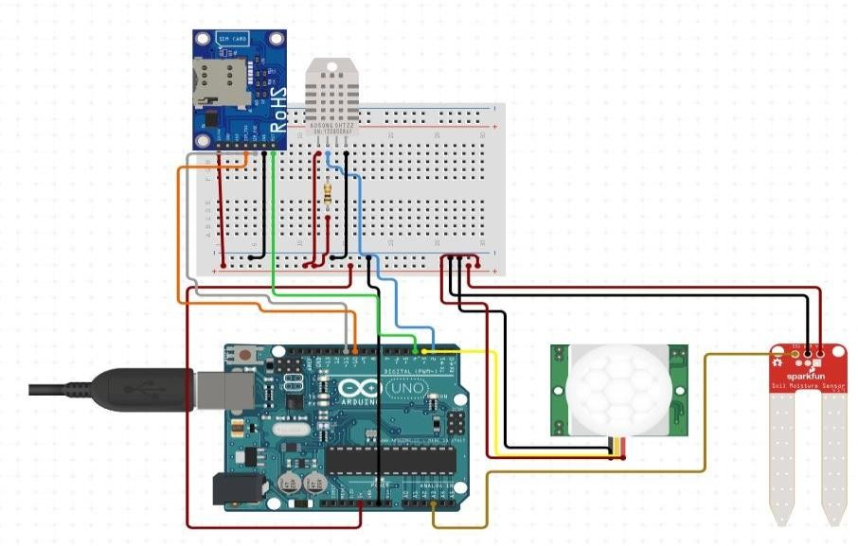

# IoT Simulator

In our project in the place of sensors we are going to use IoT sensor simulator which give random readings to the connected cloud.

We need to give the credentials of the created device in IBM Watson IoT Platform to connect cloud to simulator.

# OpenWeather API

OpenWeatherMap is an online service that provides weather data. It provides current weather data, forecasts and historical data to more than 2 million customer.

**Steps to configure:**

* Create account in OpenWeather o Find the name of your city by searching o Create API key to your account
* Replace “city name” and “your api key” with your city

and API key in below red text api.openweathermap.org/data/2.5/weather?q={city name}&appid={your api key}